**Mini Project**

**Aim:**To perform general directory/file management commands and grep commands.

**Theory :** structure of directory

The given structure is the structure of the department named IT . In the IT Department there are three subdirectories named D10 ,D15,D20. In each directory two text files are saved (attendance and marks).in the D10 folder there is one more directory named sincere which contains a file named grace.txt.



**Creating the main directory (IT)**





**Creating the subdirectories**

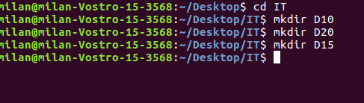

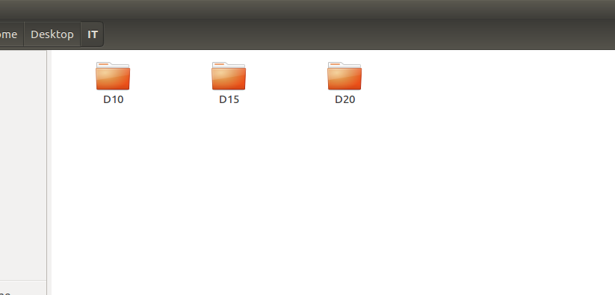

**After creating subdirectories text files are created in each directory**

**Named attendance and marks and data of the students are filled**

**And in D10 one subdirectory is created and in that grace.txt is created**

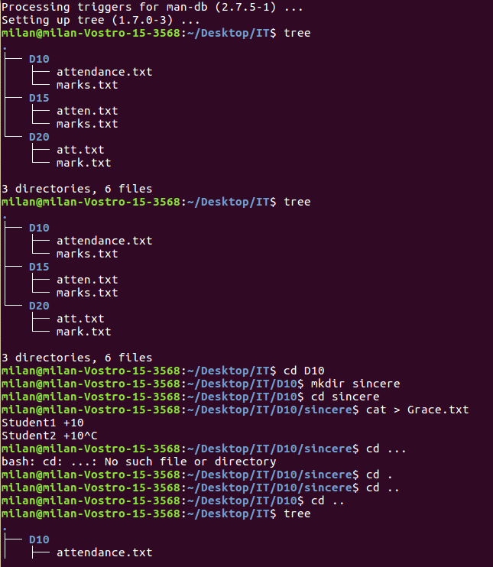

**Now for Viewing the file**

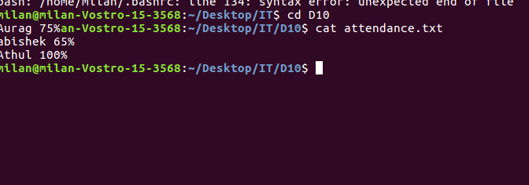

**Viewing the attendance of D15**

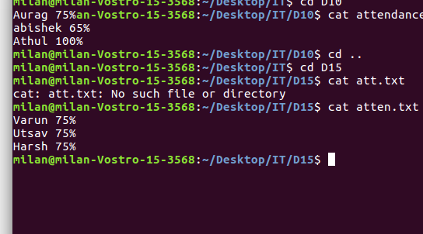

Copying a file from one folder to another.

In the below given image the folder sincere was copied to D15 directory

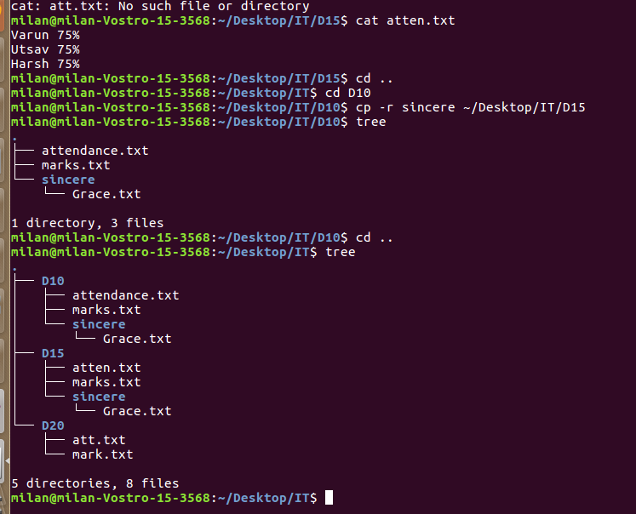

Moving files from one folder to another

In the below given image the grace.txt was moved to D20 directory

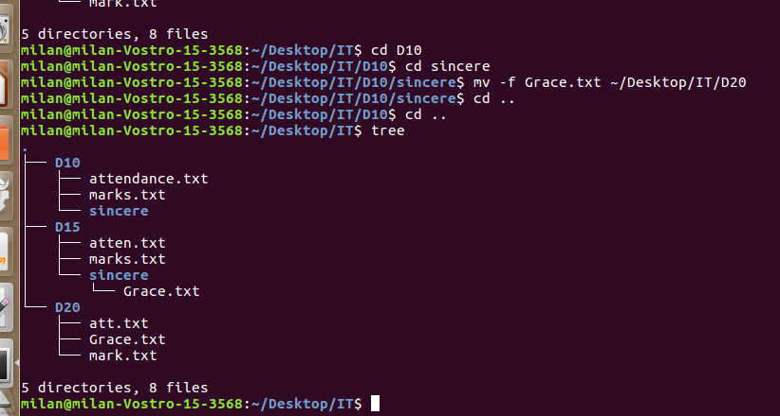

Removing a file,folder and a folder containing a file.

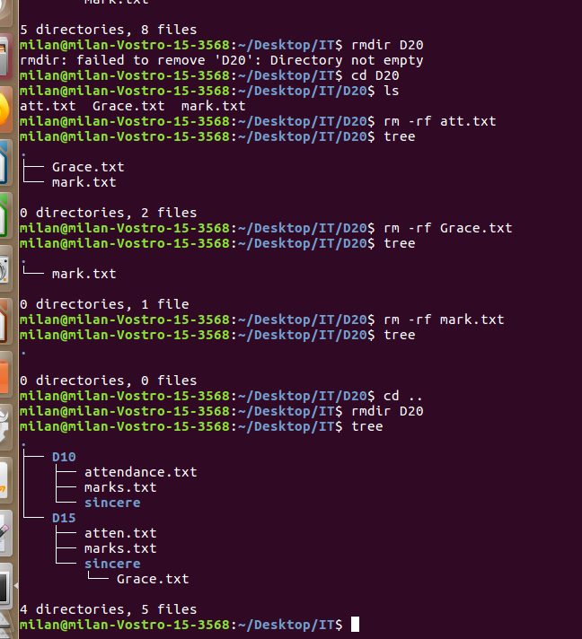

Concatenating data to a file

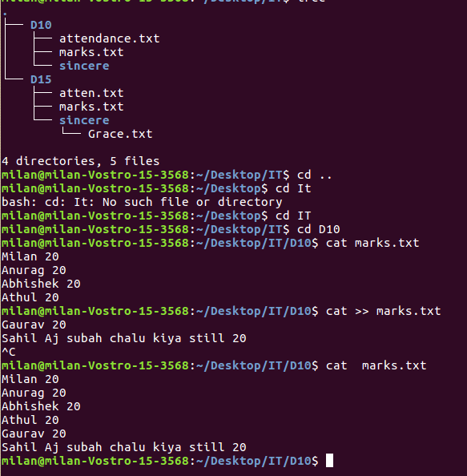

Applying chmod to a file.

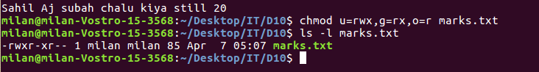

Creating a soft link for a file.

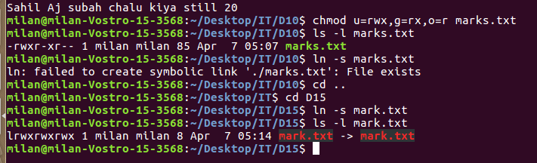

Checking the i-node

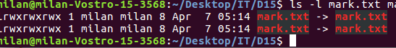

**Adding a new user in the system**

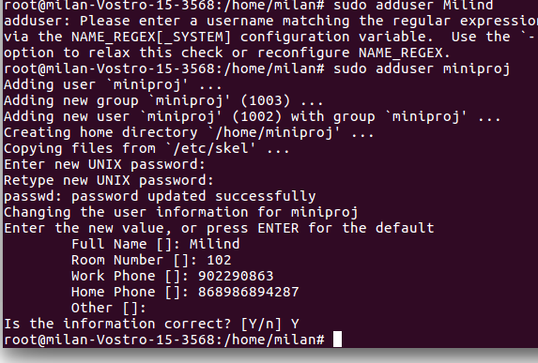

**GREP Commands**

**To find the words with the specific letters or words**

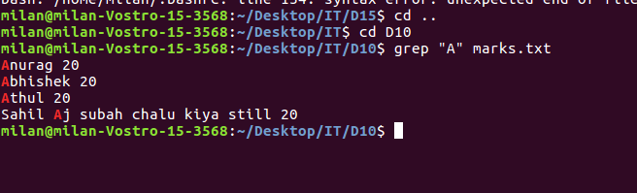

**To find all the case sensitive letters**

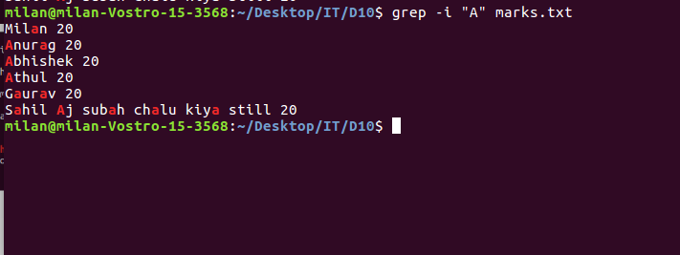

**Conclusion :** Thus user,directory management commands were successfully executed.